Miniature Digital Voice Recorder
MAG-24

Operation Manual

Contents:

PRECAUTIONS: 2
1 Description and operation 3
1.1 Purpose 3
1.2 Technical characteristics 3
1.3 Complete set 4
1.4 Design and operation of the recorder 4
1.5 Packing 5
2 Use of the recorder 6
2.1 Preparation for use 6
2.2 NOVO PC MAGic software 6
2.2.1 Installation of the software 6
2.2.2 Use of the software 6
2.3 Use of the recorder 9
2.3.1 Voice recording 9
2.3.2 Playback 9
2.3.3 Determination of operation mode of the recorder 9
3 Servicing 10
4 Storage 10
5 Transportation 10
6 Disposal 10
7 Registration information 10
8 Warranty 11

This User Manual covers the MAG-24 digital recorder (hereinafter – the recorder).
Use of the recorder does not require special training of personnel.
Before use fully and carefully read this User Manual.

PRECAUTIONS:
- Do not let water, dew or dust on the recorder.
- Avoid strong electromagnetic fields.
- Do not leave the recorder under direct sunlight for a long time.
- Do not try to disassemble the recorder. The user cannot repair it.

1 Description and operation

1.1 Purpose
1.1.1 The recorder is designed for high quality recording of voice information.
1.1.2 Recorded audio files can be downloaded to a PC for further processing. The recorder features small dimensions and weight, long battery life, wide dynamic range and microphone high sensitivity. Robust metal housing protects the recorder from mechanical shocks and dictaphone jammers.

1.2 Technical characteristics
1.2.1 Table 1 shows technical characteristics of the recorder.
Table 1 – Technical characteristics of the recorder
Name of parameter | Value
Memory size (microSD card), GB | Up to 32
Time of continuous operation (w/o VAS) with fully charged battery, hours:  - at sample rate of 12 kHz  - at sample rate of 24 kHz | 7  5
Sample rate, kHz | 12/24
Bit capacity, bit | 24
Time of recording of 1 GB, hours:  - at 12 kHz sample rate  - at 24 kHz sample rate | 6  3
Dynamic range, dB | 90
Current consumption, mA:  - recording at sample rate of 12 kHz  - recording at sample rate of 24 kHz  - в спящем режиме | 15, not more  20, not more  0,3, not more
Dimensions, mm | 49 x 26 x 10

1.3 Complete set
1.3.1 Complete set is shown in table 2.
Table 2 – complete set of the recorder Состав изделия
Name | Quantity, pcs.
MAG-24 digital recorder | 1
External microphone | 1
External microphone with amplifier (optional) | 1
Telephone adapter with connection cable (optional) | 1
Headphones | 1
Micro USB adapter for headphones | 1
USB cable (micro USB-USB) | 1
CD with drivers | 1
User Manual | 1
Packing box | 1

1.4 Design and operation of the recorder
1.4.1 The recorder performs recoding of voice information to a removable microSD memory card.
1.4.2 The recorder can use the following sources of audio signal:
(1) Internal microphone.
(2) External microphone.
(3) External microphone with amplifier.
(4) Linear input.
1.4.3 The recorder features Voice Activation System (VAS), which effectively helps increasing time of recording. Supplied software allows saving recorded audio files in *.wav format and setting parameters of the recorder.
1.4.4 Every recorded file has time and date mark, and “digital signature”, which allows determining, which recorder was used for a specific recording and were any changes introduced to a specific file.
1.4.5 There are following controls and jacks on the recorder housing (see pic 1 and 2):
- Switch
- Multifunctional jack (used as linear input and jack for connecting external microphones)
- LED indicator
- Opening for internal microphone
- Slot for microSD memory card
- micro USB socket
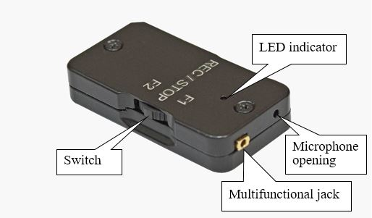
Pic. 1. The recorder view from the switch side.
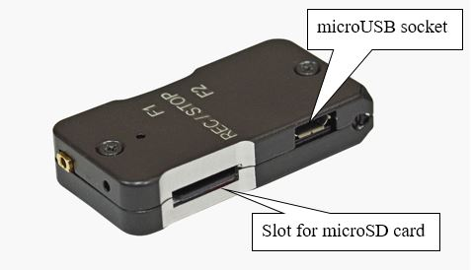
Pic. 2. The recorder view from the microSD slot side.

1.5 Packing
1.5.1 The supplied set of the recorder is packed in a plastic box (dimensions 215х150х60 mm).

2 Use of the recorder

2.1 Preparation for use
2.1.1 Before use of the recorder, install NOVO PC MAGic software on your PC (the supplied set includes CD with this software).
2.1.2 Connect the recorder to your PC with USB cable and fully charge the battery. During charging red LED blinks, LED color turning green means the battery is fully charged.
2.1.3 Start NOVO PC MAGic software and select source of audio signal. If necessary, connect external microphone. Select other required settings if any.

2.2 NOVO PC MAGic software

2.2.1 Installation of the software
2.2.1.1 Insert supplied CD with software to CD drive of your PC and run setup.exe in Windows Explorer. SmartScreen window will appear on PC display (see pic. 3):
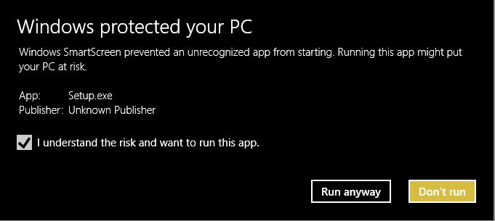
Pic. 3. SmartScreen window.
2.2.1.2 Check the box “I understand the risk and want to run this app.”, “Run anyway” button will appear. Click it with the left mouse button to let the installer proceed. Then follow instructions of the installer.
2.2.1.3 - program shortcut. The installer does not offer an option of the program shortcut placement on a desktop. If required, the user must do it manually.

2.2.2 Use of the software
2.2.2.1 Connect the recorder to your PC with USB cable.
2.2.2.2 Start NOVO PC MAGic.
2.2.2.3 Main window of the software will open (see pic. 4). Make sure that the software detected the recorder (connection status is shown in the lower left corner of the window).
2.2.2.4 Main window of the program includes the following sections:
- Record quality
- Record source
- Current time and date
- Timer recording
- Voice activation
- Battery
- Microphone gain
2.2.2.5 In the Record quality section, the user can select high (24 bit 24 kHz) or standard (24 bit 12 kHz) quality.
2.2.2.6 In the Record source section, there is selection between internal, external, external with amplifier microphones and linear input.
2.2.2.7 In the Current time and date section, it is possible to synchronize system clock of the recorder with system clock of your PC.
2.2.2.8 Timer recording section allows setting time and date of start and end of recording. To activate timer, check the box “Timer activation”. It is possible to activate repeated recording – Record every day function.
2.2.2.9 Voice activation section includes the following settings:
- Record delay. Possible values - 10; 20; 30; 40 and 50 ms.
- Activation threshold. Possible values - from 2 to 50. Setting is selected depending on surrounding conditions.
- Record off delay. Possible values - 10; 20; 30; 40 and 50 s.
Setting of abovementioned values is possible only after checking the box “Activate VAS”.
2.2.2.10 Battery section shows battery level. Value of fully charged battery is 4,20 V.
2.2.2.11 Microphone gain section. Possible values are: +16,2; +19,2; +22,3; +25,2 and +28,3 dB. Under the dropdown menu, there is the checkbox for activating microphone AGC.
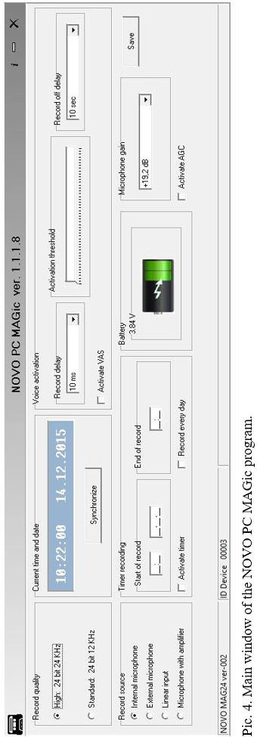

2.3 Use of the recorder

2.3.1 Voice recording
2.3.1.1 To start recording, press and hold the switch (REC/STOP) until the red LED lights up. When it goes off, recording starts. During recording, the red LED blinks with interval of 10 s. If VAS is activated, orange LED blinks. It means the recorder is ready to start operation when the set threshold will be exceeded. If timer recording is activated, the recorder starts operating in a set time.
2.3.1.2 To stop recording, press and hold the switch (REC/STOP) until the green LED lights up. At this moment, the recorder goes to standby mode. In case of timer recording, the recorder stops operating in a set time and goes to standby mode.

2.3.2 Playback
2.3.2.1 Recorded audio files can be played either on the recorder or on your PC.
2.3.2.2 To listen to recorded files on the recorder, move and hold the switch in F2 position. The green LED will light up and the recorder will go to playback mode. Connect headphones to headphones adapter and the latter to USB socket. To start playback, press the switch (REC/STOP). The green LED goes off and playback of the first audio file starts. To stop playback, press the switch (REC/STOP). To go to the next file (recording), move the switch to F1 position, to return to previous one, move the switch to F2 position. To exit playback mode, move and hold the switch in F2 position.
2.3.2.3 To listen to audio files on your PC, copy them to your computer HDD. Use standard Windows programs for listening.

2.3.3 Determination of operation mode of the recorder
2.3.3.1 Move the switch to F1 position. The LED will light up and show current operation mode:
- The LED illuminates for several seconds – the recorder is in standby mode. At that, LED color shows level of the battery charge: green – battery level is more than 50%, red – less than 50%.
- The LED blinks for several seconds – the device is recording. At that, LED color shows level of the battery charge: green – battery level is more than 50%, red – less than 50%.

3 Servicing
3.1 The recorder does not require any servicing by the user.

4 Storage
4.1 The recorder must be stored in a heated storage facility.
4.2 Storage conditions:
- Storage temperatures - + 50 ~ + 5°С.
- Relative humidity - 80% at +30°С;
- Absence of vapors of acid, alkali and other aggressive liquids.

5 Transportation
5.1 The recorder can be delivered by any mode of transportation according to general requirements to electronic goods transportation.

6 Disposal
6.1 The recorder disposal procedure is subject to local electronic equipment disposal regulations.

7 Registration information

The MAG-24 digital recorder, S/N __________________
Seller_______________________________
Date of sale __________________________

8 Warranty
8.1 The manufacturer guarantees no-failure operation and all operating characteristics during 12 (twelve) months after date of shipment by the seller, provided the customer follows all the rules, stipulated in the documentation. Mechanical damage deprives the user of the warranty.
8.2 In case the manufacturer is responsible for malfunction or failure of the device, it is guaranteed to be fixed or exchanged free of charge during 30 days after the date of receiving faulty unit.
8.3 Repairs or replacement of the device in the post-warranty period is to be done according to the additional agreement.

